2019

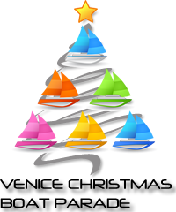
Venice Christmas Boat Parade
PO Box 1165
Venice, FL 34284-1165
www.venicechristmasboatparade.com

Officers

President
Joe Zgrzepski
joezgrzepski@gmail.com

Vice President
Charles Long
clong219@gmail.com

Treasurer
Tom Whittaker
Dowd Whittaker & Assoc., CPA’s
tom@dowdwhittaker.com

Secretary
Kristi Zgrzepski
jkfarmz28@yahoo.com

Board Directors

Patty Bozek
pbozek4935@gmail.com

Randy Underwood
runderwood@freedom
boatclub.com

Rajeana Anders
rajeanak@gmail.com

Venice Christmas Boat Parade

The Parade Committee cordially invites you to be a sponsor of the 31st Venice Christmas Boat Parade on the Intracoastal Waterways of Venice, FL. The Parade is scheduled every year for the 1st Saturday in December starting at 6pm, the route beginning north of Albee Road and traveling down to and returning at the Circus Bridge.

When Jim Hussman and a group of Venice residents decided to start the Boat Parade 31 years ago, and for the last 14 years under the direction of John Osmulski, no one realized that this annual activity of Giving Back to the Community would generate the thousands of people who view and appreciate the parade on a yearly basis. Under the leadership of the new President Joe Zgrzepski, the parade board and volunteers, the enthusiasm of our boating participants and the contributions from our area sponsors, the parade continues to be an anticipated yearly event to celebrate and enjoy the holidays. Spectators of all ages stake out their viewing position days before the parade begins and parties are planned along the waterway.

A significant portion of funding for the parade depends on sponsorships from individuals, organizations, and businesses in the community.

The Venice Christmas Boat Parade is a 501(c)(3) – not for profit, so your donation is a tax savings to you while filling a need for the area. Our sponsors will enable the Boat Parade Committee to meet those associated parade costs and fund various activities in our community such as, the Venice Boy Scouts, Venice Youth Boating, Venice HS scholarship, All Faith Food Bank, and St. Francis Rescue, to name a few.

The success of the Venice Christmas Boat Parade is made possible through your generosity. We hope we can count on your support as a sponsor. Sponsorship levels are outlined in the accompanying page.

If you have any questions, or if you would like further information, please do not hesitate to contact Joe Zgrzepski at joezgrzepski@gmail.com or
call 941-718-8644. You may also visit the web site for parade information at www.venicechristmasboatparade.com or visit us on Facebook at www.facebook.com/VeniceChristmasBoatParade/ and see how we have gone international!

Sincerely,

Venice Christmas Boat Parade Committee

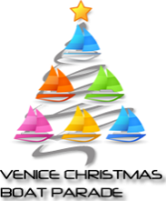
Sponsorship Levels

Admiral Sponsorship: $1000 donation – Donor’s name large and at the top on back of T-shirts
being printed
Captain Sponsorship: $500 donation – Donor’s name medium size on back of T-shirts
being printed
1st Mate Sponsorship: $300 donation – Donor’s name printed on back of T-shirts being
printed
Deckhand Sponsorship: $299 or less - Recognition on Parade web site

- Recognition of all sponsorship levels on official Boat Parade web site
- Recognition on the Venice Boat Parade Facebook page
- $20 Boat Entry Application fee waived (fill out application – on web site)

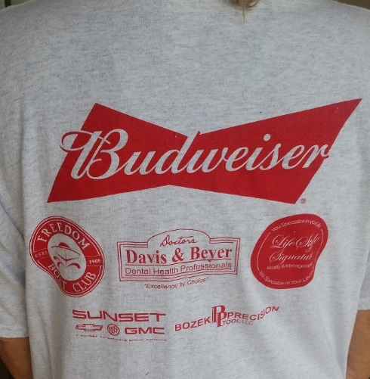
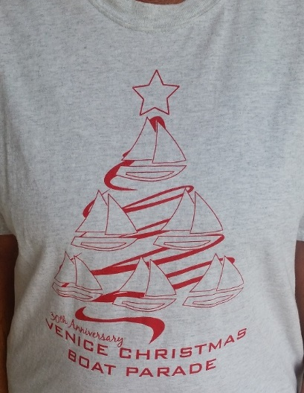
If your business would like to go above the mentioned sponsorships
and would like to host the parade in our Giving Back to the Community,
please contact Joe Zgrzepski directly.

We ask that you please fill out the information on the next page (and if entering a boat complete the application which is on our web site) and submit your donation before October 16th 2019.

Of course, any type of donation is welcomed and appreciated.

Besides your donation - Everyone is invited to participate, big boats, small boats, power or sail!

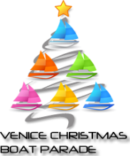 RESPONSE FORM

Name of Organization: _____________________________________________________________

Contact Name: ____________________________________________________________________
Address for Correspondence: ________________________________________________________
e-mail Address: ___________________________________________________________________
Phone #’s: _______________________________________________________________________
Sponsorship Level: ________________________________________________________________
Signature/Title: __________________________________________________________________

Please attach a copy of your Organizations’ Logo; either a business card or stationary which has a crisp view of your logo.

Please mail this form and your donation to:

Venice Christmas Boat Parade, Inc.
PO Box 1165
Venice, FL 34284-1165

